### 

### 

### 

Lock-in Amplifier

E72 Final Project Report

Kelvin Paa Kwesi Adjei and Michelle Kim

Table of Contents

Abstract **3**

Introduction **3**

Background **4**

Filters 4

Fourier Transform 5

Lock-in Amplifier 5

Photodiode 5

Low Pass Filter for DC value 5

Theory **6**

Project Design **8**

Results **12**

Discussion **14**

Appendices **14**

References **15**

### 

## Abstract

Lock-in amplifiers can detect and measure extremely small signals more precisely than your everyday filter. They are used to precisely measure AC voltage amplitudes and phase shifts in a wide range of applications. While there are digital lock-in amplifiers that use an analog-to-digital converter and analyze the signal using digital signal processing, we wanted to explore the use and theory of using filters, multipliers, and amplifiers in combination to achieve the final result. Our goal is to implement a lock in amplifier that is capable of detecting a specific carrier wave through the noisy signal of a photodiode. The lock in amplifier takes an input from the photodiode and a predetermined reference wave of frequency *f* and outputs the amplitude of the signal of frequency *f* in the input signal. The lock-in amplifier accomplishes this by manipulating the input signal in four stages: pre-amplifier, multiplier, low-pass filter, and output amplifier.

## Introduction

In this project, we hope to implement a lock-in amplifier circuit that takes in the input of a photodiode and can lock-in on the blinking frequency of a standard LED. This was an interesting project for us because we have never implemented or heard of something like the lock-in amplifier. It was exciting to turn concepts into an electrical circuit and create something that works in real time. This was also interesting to us because the lock-in amplifier is so powerful at what it does. Other methods for extracting frequencies that we discussed in class do not have the level of precision that the lock-in amplifier provides. The lock-in amplifier also has phase-detection capabilities that we had hoped to explore. These characteristics make lock-in amplifiers “workhorses in all kinds of laboratory setups, from physics to engineering and life sciences” (Zurich Instruments, 2016).

## Background

### Filters

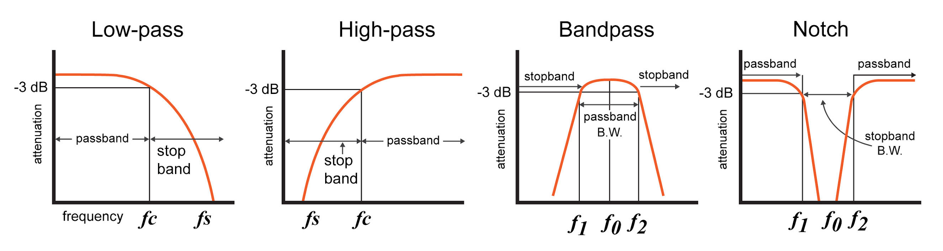

*Figure 1. Types of Filters*

One method of manipulating the signal based on frequency is to use filters. There are a variety of filters that are very simple to implement using standard resistors and capacitors. However, filters are used to dampen the presence of a range of frequencies and preserve the presence of another range of frequencies. This works well when you are trying to clean noise that is far away from the frequency of interest, but does not completely isolate one frequency. Even the bandpass filter, which tries to close in on one frequency, cannot precisely lock in on one frequency- there will always be a bandwidth of frequencies that passes through the filter.

### Fourier Transform

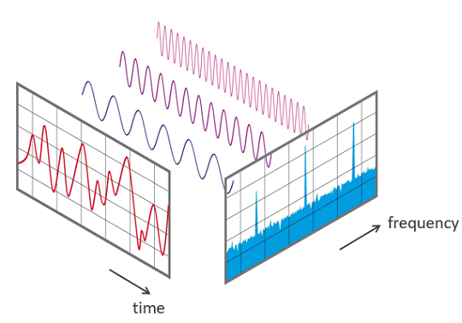

*Figure 2. Visualization of Fourier Transform*

The fourier transform is another method of analyzing a signal at a specific frequency. The mathematical function is used to break down a complex signal into uniform waves of distinct frequencies. This is a more precise method than analog filters. However, if we were to use a fourier transform, we would have to use an analog-to-digital converter to perform numerical analysis. This causes a delay and may inaccurately portray information of the wave in real time.

### Lock-in Amplifier

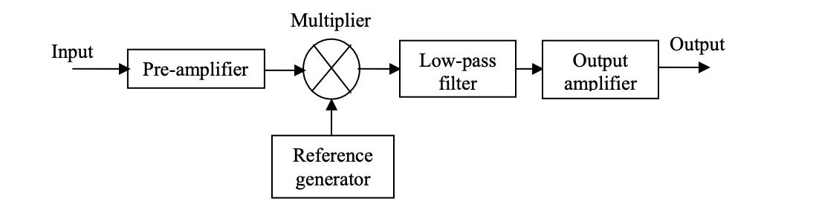

*Figure 3.* Lock-in Amplifier Block Diagram

The lock in amplifier is made up of four components. The input first goes through an amplifier. This amplified signal is then fed into the multiplier with the reference wave that is the same frequency as the signal that one is looking for in the input. This multiplied output goes through a low pass filter, which is configured so that all noise is eliminated and only the DC value is left. Finally, the DC value is amplified. This DC value represents the strength of the presence of a signal of the desired frequency.

Unlike the two options above, this provides a way to precisely lock in on a signal of a certain frequency without any time delay.

### Photodiode

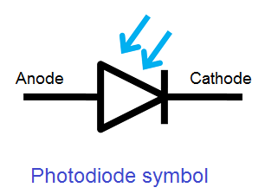

*Figure 4.* Photodiode symbol

A photodiode is a device that absorbs photons, causing a current through the wire when light is detected. We wanted to use this device because there is often noise in detecting light. We wanted to see if, despite the light present in the room and the moving environment of the lab, the lock-in amplifier could extract the signal of the LED that is blinking at the frequency of the reference wave.

## Theory

The Lock-in amplifier provides a very narrow band pass which filters out most of the noise in our signal including those which are produced when we amplify the output. The lock in amplifier acts both as a detector and a narrow-band filter.

The essential part of the lock-in amplifier consists of a signal mixer which works based on the principle of the orthogonality of sinusoidal functions. This principle states that when two sinusoidal functions of different frequencies are multiplied and integrated over a long period of time, the result is zero when the frequencies of both signals are different or the signals are out of phase. However, when the frequencies are the same and the functions are in phase, the average is the product of half the product of the magnitudes of the amplitudes of both sinusoidal functions.

Mathematically,

Assume we have two sinusoidal functions:

$F($ ω) = Asin(ωt + ɸ )

ω1) = Bsin(ωt + ɸ )

By principle of Orthogonality of sinusoidal function:

$\frac{1}{T}$ $\int_{t-T}^{t}{}($ $F($ ω) $G($* ω))dω = $\frac{1}{T}$ $\int_{t-T}^{t}{}(Asin(ωt + ɸ )*Bsin(ωt + ɸ )))dω$

= $\frac{1}{T}$ $\int_{t-T}^{t}{}(ABsin^{2}(ωt + ɸ ))dω$

= $\frac{1}{T}$ $\int_{t-T}^{t}{}AB[ \frac{1}{2}(1 -cos(2(ωt + ɸ ))]dω$,( From trigonometric identities, $sin^{2^{}}(x)= \frac{1}{2}(1 -cos(2x))$

= $\frac{1}{2}AB$

As our signal mixer, we used a synchronous demodulator (AD630) which is a high precision balanced modulator demodulator which provides precise closed loop gains of +/-2. For our purpose of signal mixing, the in-built comparator in AD630 — whose positive and negative terminals are attached to pins 10 and 9 — is connected to the ground and reference input at pins 9 and 10 respectively. A phase-shift oscillator could be used to keep our reference signal in phase with the input signal we want to filter. The input is also fed into both an inverting op-amp and a non inverting op-amp of gain -2 nad +2 respectively. The AD630 then compares the input with the reference signal, and then uses the principle of orthogonality of sinusoidal functions to detect and filter out noise from our wanted signal.

## Project Design

To design our lock-in amplifier, it was important to understand the several parts our lock-in amplifier was going to be divided into and how each of these parts were relevant in making the lock-in amplifier implementation fruitful. We managed to obtain that our device could be made of five parts namely:

* Input: The input of our lock-in amplifier is generated by a photodiode. This photodiode acts as a current source by producing mA of current when light is detected by it. A resistor is connected in parallel across the photodiode to produce an equivalent voltage source which supplies voltage to our input amplifier. We chose a 1kΩ resistor as the resistor that is connected in parallel with our photodiode to produce an equivalent voltage source. It is important to note that the equivalent voltage source generates voltage that have low magnitudes thus we amplify our input in the next step.
* The input amplification part: This part consists of an instrumentation amplifier (AD620) of finite gain whose gain could be managed by connecting a resistor across pins 1 and 8 of the amplifier. Like any other instrumentation amplifier, ours takes the input through pins 2 and 3 and then amplifies the input based on the resistor that was connected across pins 1 and 8. Leaving pins 1 and 8 open gives a gain of 1x and connecting a resistor of resistance value 5Ω could give as much as 10,000x amplification. For our project, we chose a resistor that provides us with amplification large enough for us to enable us to transfer a signal of higher voltage to our signal mixer but not large enough to cause clipping of our output when we pass our signal through active filters later.Taking these specifications into consideration, we decided to use a 1 kΩ resistor which amplifies our input signal by a factor of 50x. Figure 5 shows us the internal connection diagram of the input amplifier (AD620) and shows what each pin is connected to. The output of the amplifier is connected to pin 6, the negative and positive inputs to pins 2 and 3 and the voltage rail supplies to pins 4 and 7.

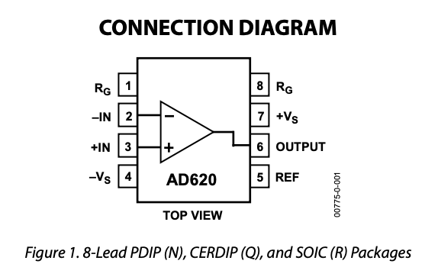

Figure 5 AD620 connection diagram.

* Synchronous Demodulator and Low pass Filter: The next part of our lock-in amplifier we decided to have was the synchronous demodulation part. This part, which is the most essential part of the lock-in circuit was implemented by connecting our amplified input signal and reference signal to a synchronous demodulator(AD630) which mixes both signals and multiplies them together with a gain of +/- 2. To get a detailed understanding of how the synchronous demodulator works, it is important to know that the AD630 is configured such that the reference signal is connected to the positive terminal of an in-built comparator which has its negative terminal grounded, the input is then fed to an inverting and a non-inverting op amp of absolute gain 2. This is then connected to the comparator and the comparator outputs a positive signal that has gain +2 when the product of the signal and the input signal are positive and -2 when the product is negative. The output of the synchronous demodulator is then passed to a low pass filter which filters out the noise and outputs a DC signal whose magnitude is equal to the product of the amplitudes of the amplified input signal and the reference signal. We implemented our low pass filter to be small enough to eliminate signals of frequencies that are about the value of our reference signal frequency or larger. We chose to build a low pass filter with a cutoff frequency 30.3 rad/s of about and a time constant of $33 ×10^{-3}s$. Figure 6 shows a connection diagram of our synchronous demodulator (AD630) showing what each of the pins are connected to. The reference signal is connected to pin 10 and pin 9 is grounded. The amplified input is connected to pins 1 and 16. Pins 17 and 14 are grounded and pins 11 and 8 are connected to a positive and negative DC voltage source respectively.

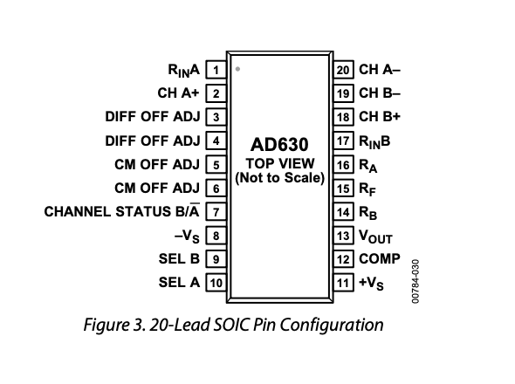

Figure 6. Connection diagram of AD630.

* Output Amplification: After the output has been amplified, we pass the DC signal that is output by the low pass filter through a precision amplifier(OP 27) which also has finite gain that can be controlled by connecting a resistor across pins 1 and 7. We set our output amplifier to produce an output of gain 10 by connecting a 10 kΩ reistor across pins 1 and 7 of OP27. Figure 7 shows a connection diagram of our output amplifier with the description of what is connected to each pin.

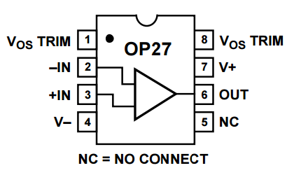

Figure 7. Connection diagram of OP27.

* Output : The output of the lock-in amplifier is expected to be a DC signal which has a magnitude of about 500x the product of the amplitude of the magnitude of our desired input signal and reference signal. The output of the whole circuit is viewed by connecting an oscilloscope to the output pin (pin 6) of our output amplifier and we expect to get a DC signal whose slew rate is fairly small and takes some time to reach its peak value due to the slow time decay constant of our low pass filter.

These parts basically give a description of how we went about designing our lock-in amplifier. Figure 8 below shows a diagrammatic flow of how our parts come together to work effectively as a lock-in amplifier.

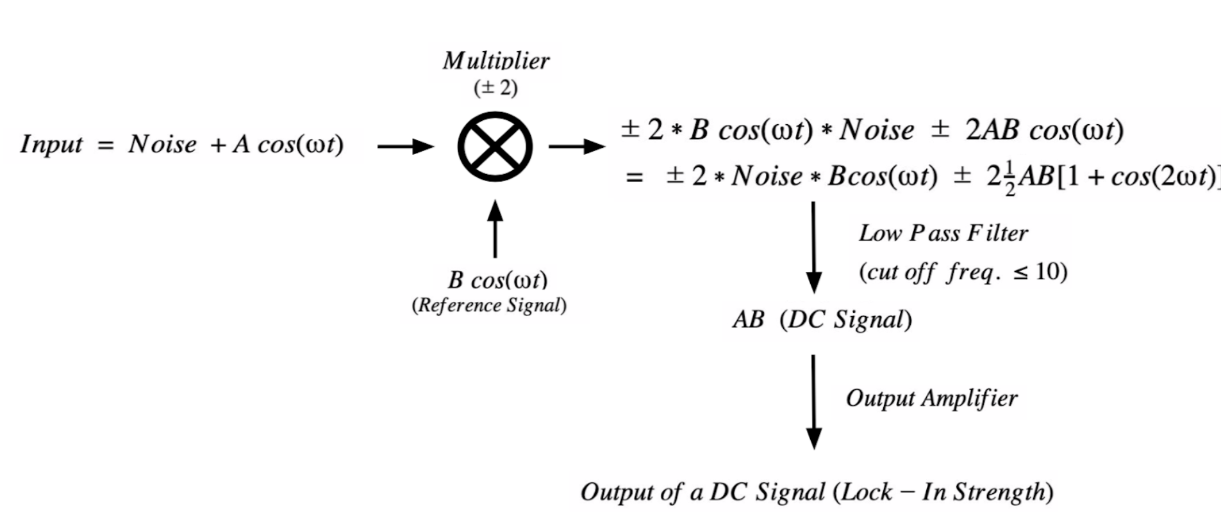

Figure 8. Diagram showing Math behind lock in.

## Results

The output of our lock in amplifier is a DC signal with an average value proportional to the product of the amplitudes of our desired input and output. The average value of our output signal was 0.987 V, the amplitude of our desired input is 50mV and the amplitude of our reference signal is 89mV. Thus, as expected from our theory, the DC signal that is 500x the product of these amplitudes.

Figure 9 below show an image of the output signal, reference signal and output form our synchronous demodulator. Figure 10 also shows the desired input and as shown these images, the average of the DC signal was approximately equal to the products of the amplitudes of the reference and desired signals as expected.

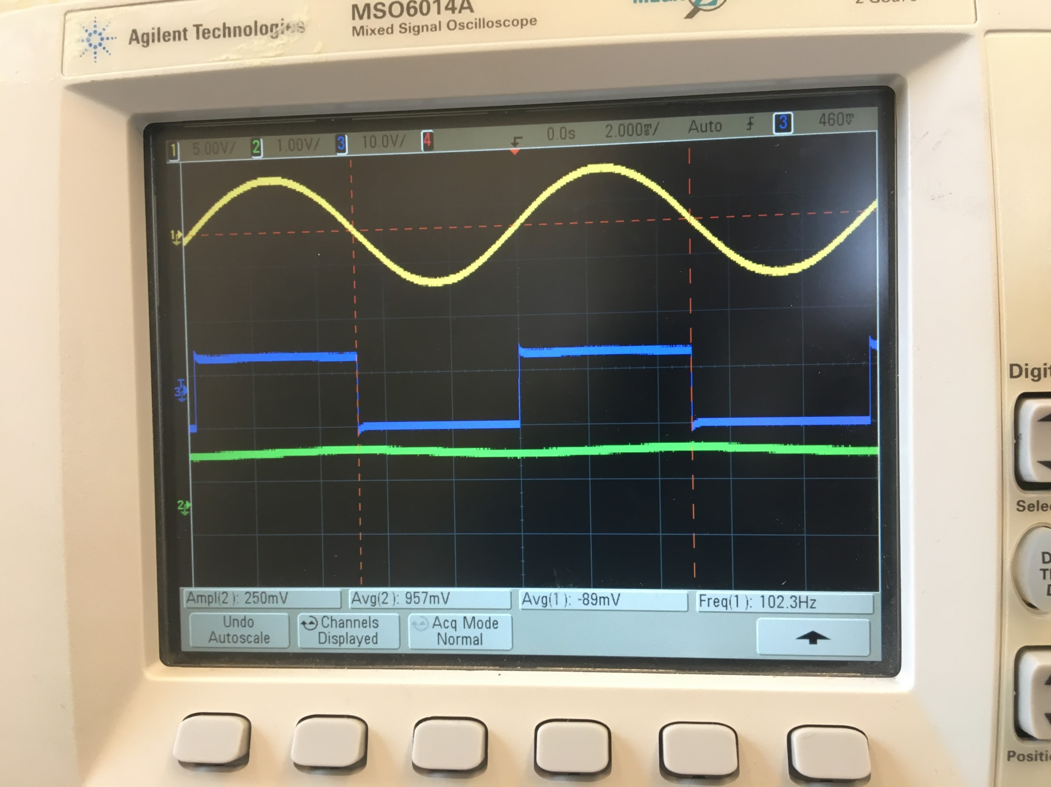

Figure 9. Output of Lock In amplifier

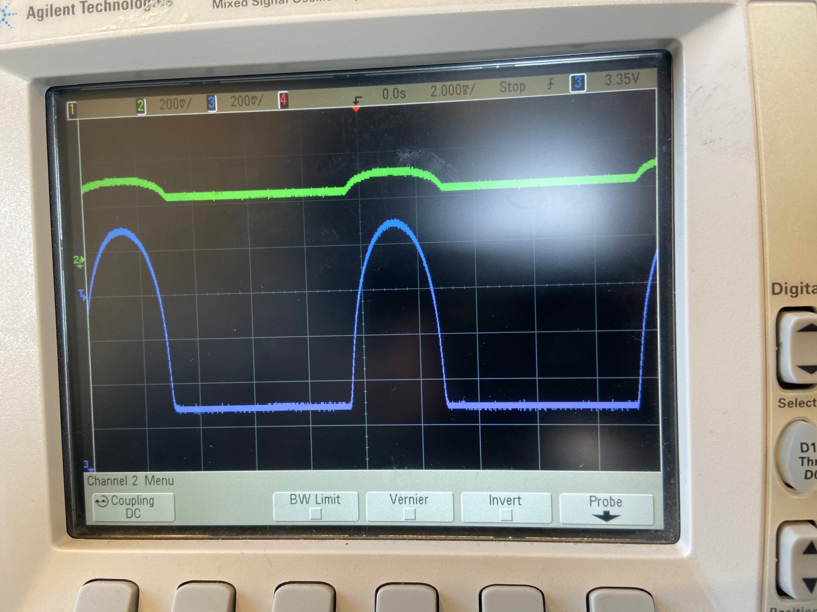

Figure 10. Desired Input and Amplified input

Figure 11 shows how our synchronous demodulator mixes with our input signal with our reference signal using the principle of orthogonality of sinusoidal functions. It is important to note that the output of the synchronous demodulator has a gain of 2 and works exactly as explained in the theory.

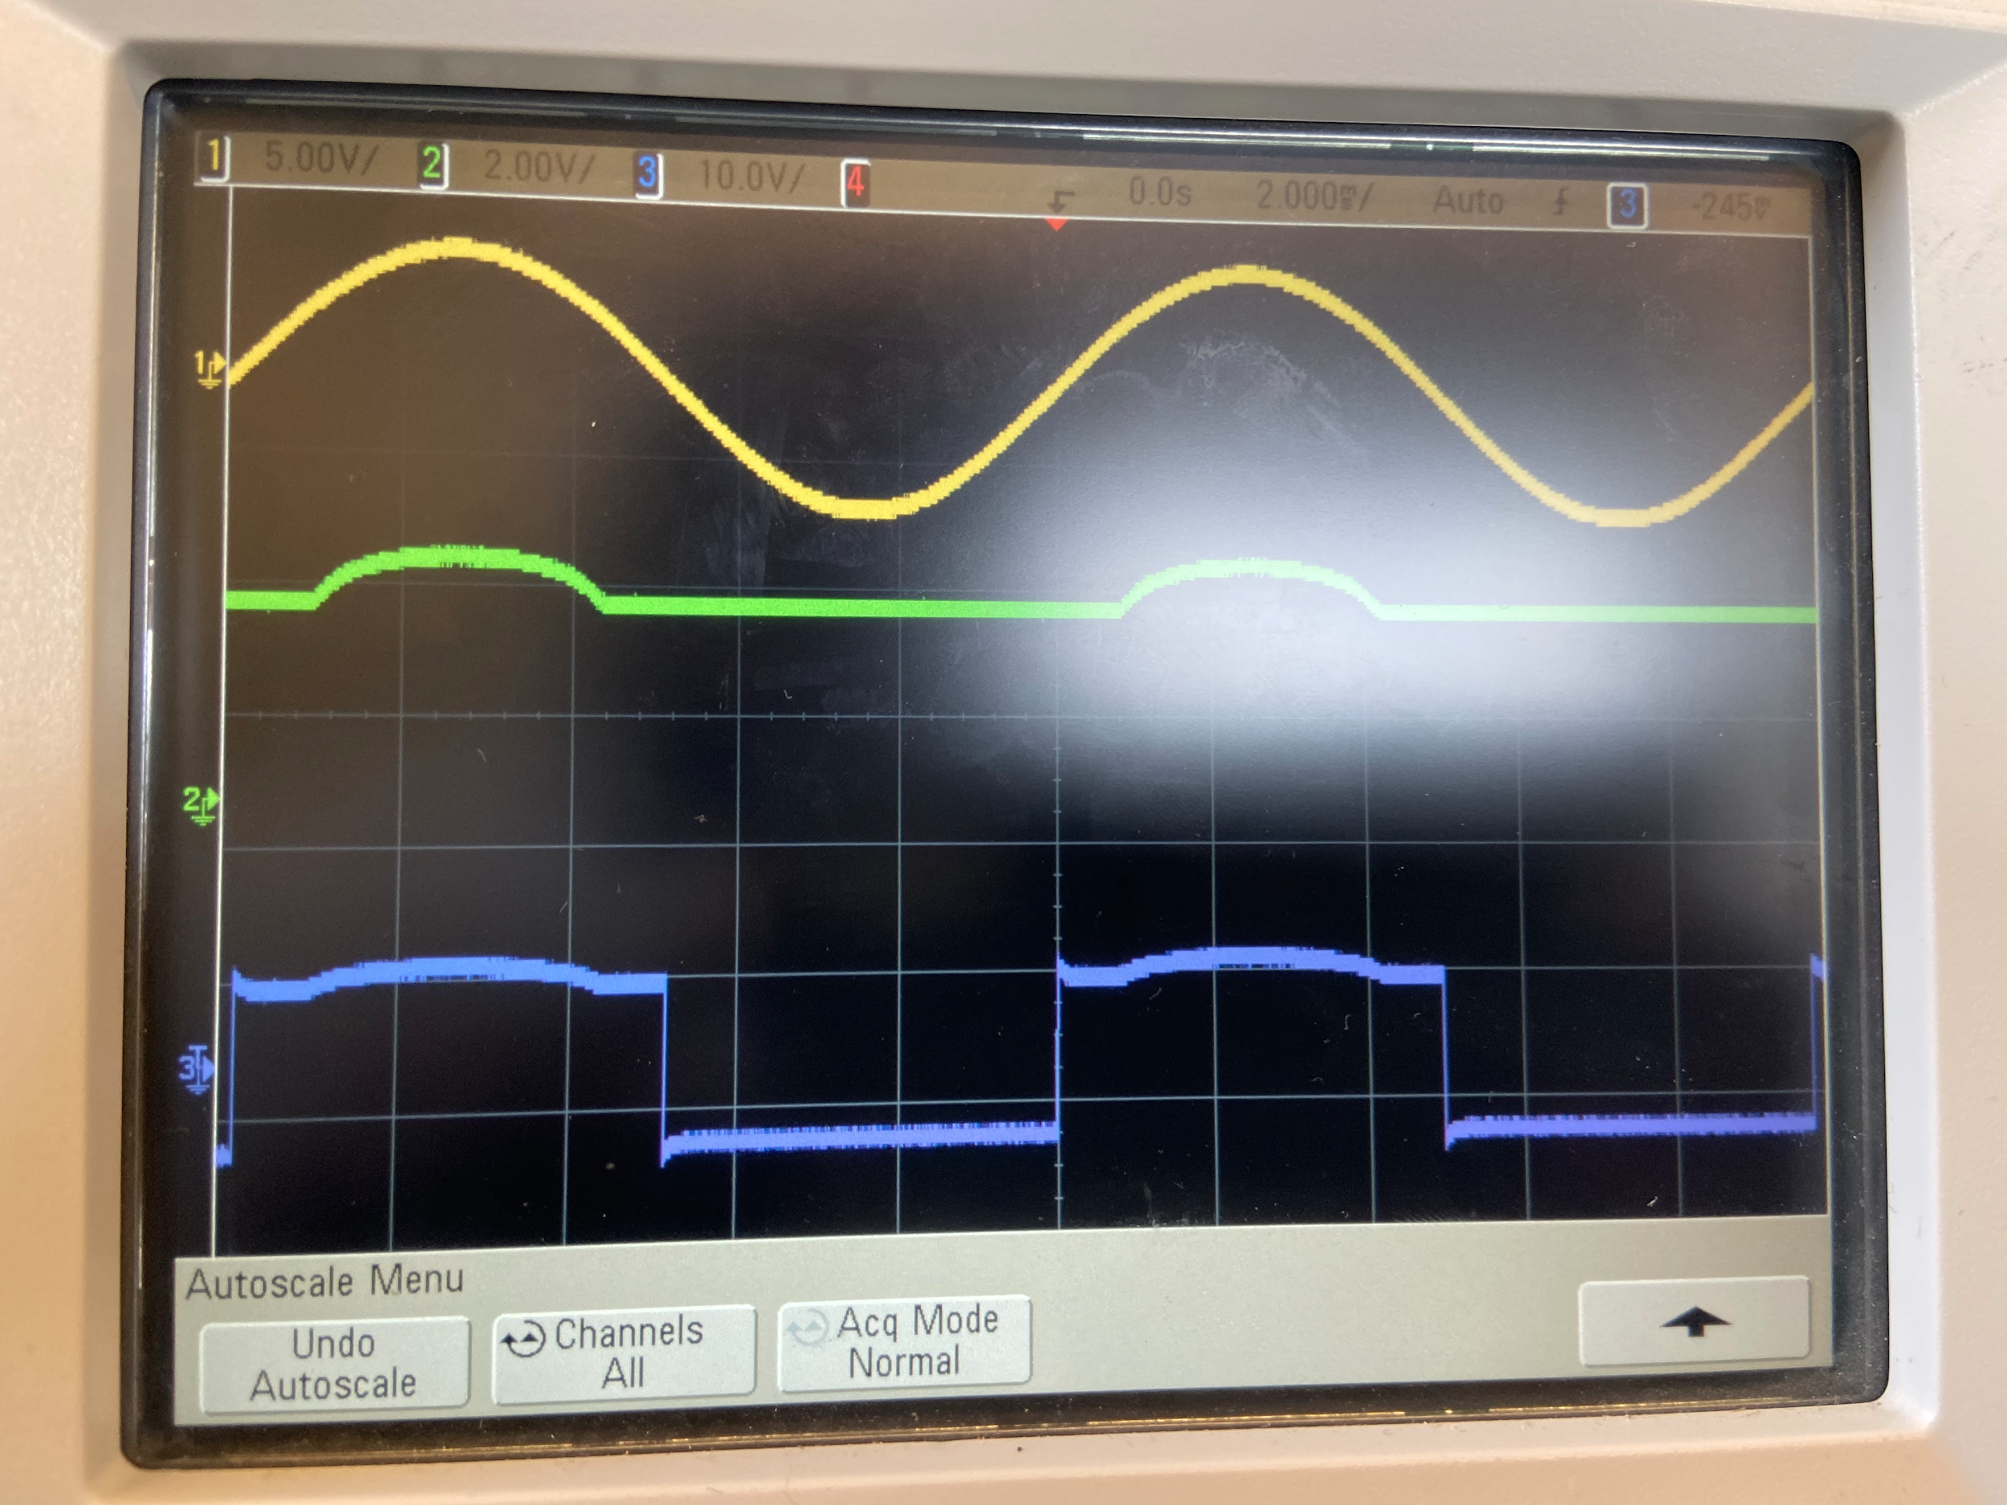

Figure 11. Output of AD630 (Input = Desired Signal Only)

## Discussion

The input amplifier, the low pass filter, and the output amplifier all worked as expected on their own. The most difficult part of our project was implementing the Synchronous Demodulator AD630. This is a new integrated circuit that we have not worked with before, but all of the literature and online tutorials pointed towards using the AD630. We originally thought of the AD630 as a wave multiplier and tried to use it as such, but the implementation of the chip was much more complex.

In the future, we would like to figure out how to utilize the phase detection functionality of the lock-in amplifier. Phase detection is not something that is implemented, but it is something that can be observed in the DC output of the lock-in amplifier. The difference in the phases of the two signals (input and reference) contribute to the output voltage of the amplifier. The Zurich Instruments manual discussed the use of lock-in amplifiers as “AC phase meters”. We would be interested in exploring how the DC output could be analyzed to detect and measure phase.

## Appendices

Lock-in Amplifier Demonstration

<https://drive.google.com/file/d/1k2QiR2jV74NbqnUOz9kb8ha5kxZuEmnM/view?usp=sharing>

## References

*Analog Multiplier Data Sheet AD633*. <https://www.analog.com/media/en/technical-documentation/data-sheets/AD633.pdf>.

*Building a Lock-in Amplifier* . Princeton University, [www.princeton.edu/~romalis/PHYS312/Lock-in%20amplifier.pdf](http://www.princeton.edu/~romalis/PHYS312/Lock-in%20amplifier.pdf).

Instructables. “Lock-in Amplifier.” *Instructables*, Instructables, 15 Oct. 2017, [www.instructables.com/id/Lock-in-Amplifier/](http://www.instructables.com/id/Lock-in-Amplifier/).

Zurich Instruments, 2016. “Principles of Lock-in Detection and the State of the Art.” *Zurich Instruments*, Zurich Instruments, Nov. 2016, [www.zhinst.com/applications/principles-of-lock-in-detection](http://www.zhinst.com/applications/principles-of-lock-in-detection).